Understanding the Timer & Proximity Check Logic
Module | ET4047
Date | 01/11/2026
Lab No. | Lab 7
Author | Luke Griffin

1 Purpose of This Lab
This lab helps you understand how a state-based timer works and how elapsed time is tracked only when a sensor or switch condition is true. You will compare a LabVIEW timer sub-VI with an equivalent Arduino implementation so you can implement the logic in your assignment.
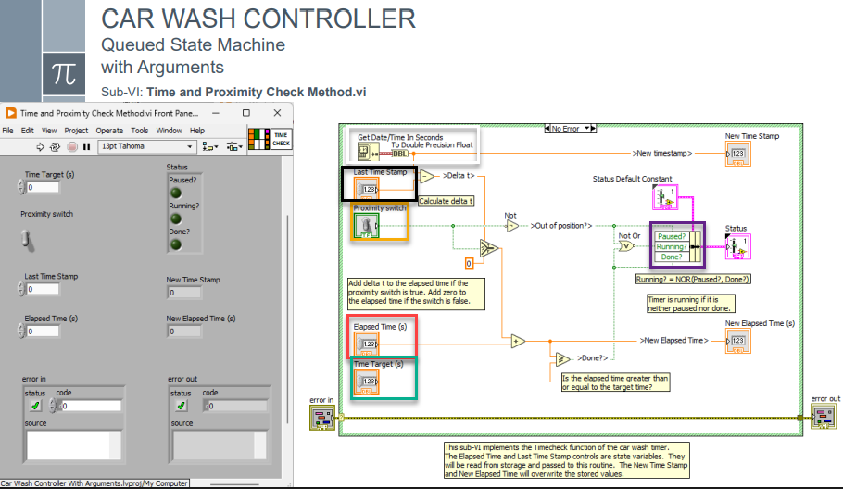
Figure 1: LabVIEW implementation of the Timer (Time and Proximity Check sub-VI)
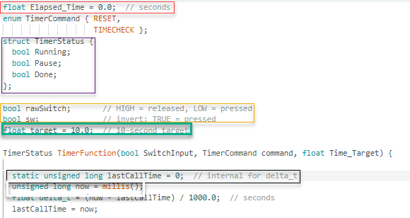
Figure 2: Arduino IDE output (Timer.ino)

2 System Overview
Both the LabVIEW VI and the Arduino function accomplish the same tasks:
• Measure time between calls (Δt).
• Add Δt to a stored elapsed time only when the switch is active.
• Output three timer states: Running, Paused, Done.
• Allow a RESET command that clears all state and elapsed time.

3 Inputs & Outputs

Inputs
• SwitchInput / Proximity Switch Boolean: TRUE when an object is present.
• Time_Target: required total time.
• command: RESET or TIMECHECK.
• lastCallTime / Last Time Stamp: used to compute Δt.

Outputs
• Running
• Pause
• Done
• Elapsed_Time
In the Arduino code the inputs and outputs are declared at the top of the sketch:
Comparison | Arduino code (Timer.ino)
LabVIEW  • Front-panel controls (inputs) and indicators (outputs) of the sub-VI.  • The three status Booleans are bundled into one Status cluster.  Arduino  • The command is an enum with two values: RESET and TIMECHECK.  • The status cluster becomes a struct TimerStatus holding Running, Pause and Done.  • Elapsed_Time is a global so it keeps its value between calls (like the shift register / Elapsed Time terminal in LabVIEW). | 1 float Elapsed_Time = 0.0; // seconds  2 enum TimerCommand { RESET, TIMECHECK };  3 struct TimerStatus {  4 bool Running;  5 bool Pause;  6 bool Done;  7 };  ⋮  13 TimerStatus TimerFunction(bool SwitchInput, TimerCommand command, float Time_Target) {  Timer.ino, lines 1–7, 13

4 Step-by-Step Logic Comparison
Each part of the LabVIEW VI is shown on the left, with the matching lines of the Arduino sketch on the right.

4.1 Time Step Calculation (Δt)
Comparison | Arduino code (Timer.ino)
LabVIEW  • Uses Get Date/Time In Seconds.  • Subtracts the Last Time Stamp → produces Δt.  • Updates the stored timestamp.  Arduino  • now = millis() reads the time in milliseconds.  • delta_t = (now - lastCallTime) / 1000.0; converts to seconds.  • lastCallTime = now; stores the timestamp for the next call. It is static, so it is kept between calls. | 15 static unsigned long lastCallTime = 0; // internal for delta_t  16 unsigned long now = millis();  17 float delta_t = (now - lastCallTime) / 1000.0; // seconds  18 lastCallTime = now;  Timer.ino, lines 15–18

4.2 RESET Command
Comparison | Arduino code (Timer.ino)
LabVIEW  • Clears the Elapsed Time.  • Clears the Running, Paused and Done states.  Arduino  • Elapsed_Time = 0.0;  • Running = false;  • Pause = false;  • Done = false;  • return exits straight away, so no time is added. | 25 if (command == RESET) {  26  27 Elapsed_Time = 0.0;  28  29 status.Running = false;  30 status.Pause = false;  31 status.Done = false;  32  33 return status;  34 }  Timer.ino, lines 25–34

4.3 TIMECHECK Command

4.3.1 Update Elapsed Time
Comparison | Arduino code (Timer.ino)
LabVIEW  • Adds Δt only when the proximity switch = TRUE (Select / case structure on the switch).  Arduino  • if (SwitchInput) Elapsed_Time += delta_t;  • When the switch is FALSE, Δt is thrown away and the elapsed time holds its value. | 39 if (command == TIMECHECK) {  40  41 // Update elapsed time only when Switch = TRUE  42 if (SwitchInput) {  43 Elapsed_Time += delta_t;  44 }  Timer.ino, lines 39–44

4.3.2 Pause State
Comparison | Arduino code (Timer.ino)
LabVIEW  • Pause = NOT(SwitchInput)  Arduino  • Pause = !SwitchInput | 46 // Logic definitions  47 status.Pause = !SwitchInput;  Timer.ino, lines 46–47

4.3.3 Done State
Comparison | Arduino code (Timer.ino)
LabVIEW  • Elapsed_Time ≥ Time Target (Greater Or Equal? comparison).  Arduino  • Done = (Elapsed_Time >= Time_Target) | 48 status.Done = (Elapsed_Time >= Time_Target);  Timer.ino, line 48

4.3.4 Running State
Comparison | Arduino code (Timer.ino)
LabVIEW  • Running = NOR(Pause, Done)  Arduino  • Running = SwitchInput && !Done  • Same logic: NOT(NOT(SwitchInput) OR Done) = SwitchInput AND NOT(Done). | 50 // Running = NOT( NOT(SwitchInput) OR Done )  51 // = SwitchInput AND NOT(Done)  52 status.Running = SwitchInput && !status.Done;  53  54 return status;  Timer.ino, lines 50–54

5 Key Takeaways
• This is a polled timer, updated on each function call.
• The switch acts as a gate for timing.
• Running, Paused and Done are derived entirely through Boolean logic.
• LabVIEW and Arduino code follow identical logic paths in different representations.

